A

Mini Project Report

On

“Phone Book”

Submitted to

SHRI - SHANKARACHARYA TECHNICAL CAMPUS
BHILAI

in partial fulfillment of the requirement of for the award of degree

Of

Bachelors of Technology

In
COMPUTER SCIENCE AND ENGINEERING
By
Jeet Verma


DEPARTMENT OF COMPUTER SCIENCE AND ENGINEERING
SHRI SHANKARACHARYA TECHNICAL CAMPU,
JUNWANI, BHILAI(C.G.)

SESSION 2021-2022

CERTIFICATE

This is to certify that the thesis report of the project submitted is an outcome of the project entitled “Phone Book” carried out by Jeet verma bearing Roll no. 23 carried out under my guidance and supervision for the award of Degree in B.Tech in Computer Science and Engineering of shri-shankaracharya technical campus, Bhilai(C.G.),India.
To the best of my knowledge the report.

(1)Embodies the work of the candidates herself/himself.
(2)Fulfills the requirements of the ordinance relating to the B.Tech Degree of the University and ,
(3)Is up to the desired standard for the purpose of which is submitted.

(Signature of the Class Teacher)
Nidhi Chandrakar
Professor
Computer Science & Egineering Department
Shri ShankaraCharya Technical Campus
Bhilai(C.G.)

The project work as mentioned above is hereby being recommended and forwarded for examination and evaluation.

(Signature of Head of Department with seal)

ACKNOWLEDGEMENT

I would like to express my special thanks and gratitude to our Mrs. Nidhi Chandrakar (project incharge ) who gave me this opportunity to represent the mini-project on the topic of ‘Phone Book’ which helped me in enhancing my knowledge of web-development from basic implementation level .
I would also like to thank Mr. Haris Khan (codewithharry.com) in making my project.

Abstract
Phone book system is small web project, in older days we stored all our important contact details in phonebook. Here using this project we can store all details in central repository.

In manual method if we forgot information book then it very difficult to get the contact details. By using this, we can see our contacts anywhere in the world. Here we will have security to the login page and no one can see our contacts with proper authentication. In this project we can save our contacts, address and we can see all them at a time.

This system is developed using the general requirement by the user while using the phone directory book. In order to keep updated the phonebook directory, the admin will have the authority to add and delete as well as modify the existing records within the phonebook directory.
INDEX

S.no. | Topic
01 | Introduction
02 | Tools and Technology used
03 | Refrences used
04 | Working with project explain with snapshot
05 | Conclusion and future use

Introduction

“Phone Book” website is created to manage the records of phone numbers. This contains the information of Name, Number, Address and Designation .Personal information such as Name, Address and Designation are asked while adding a new record into the Phonebook. These records can then modified, listed and removed.

This is very useful now-a-days to store complete information under single contact number.

It becomes easy for the user to store complete information about his contact. Adding new records, listing them, modifying them, updating and deleting the phonebook records are the basic functions which make up the main menu of this Phonebook application.

Tools and Technology Used

Languages Used :

- Javascript
- HTML
- CSS
- PHP

Code Editor Used :

- Visual Studio Code

Database Used :

- Mysql

IDE Tool used :

- XAMPP

Refrences

Video tutorials
- Web-development course by Haris khan (codewithharrry.com).
- Front-end-development by udemy (@udemy.in.com)

Books
- Mastering HTML, CSS and JavaScript By Laura Lemay.
- JavaScript and jqery by jon Duckett.

Working With Project
* Login Page :

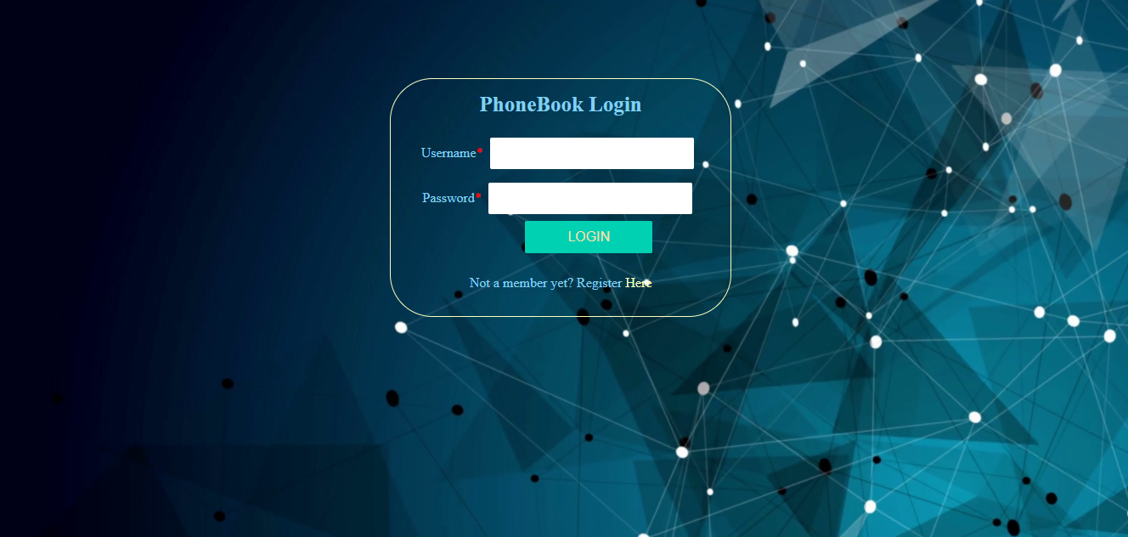
( Fig :- 01 Login page)

This is the login page of the “Phone Book” website. Only one admin at a time can login to this website. The admin can access the site by entering correct password and username.

* Home Page :

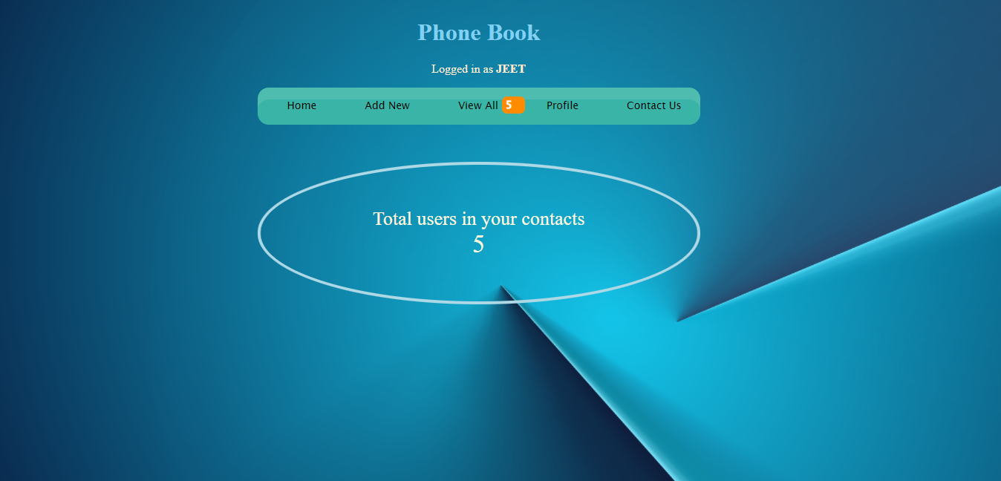
( Fig :- 02 Home page)

This is the home page of the website. This is the main page or the main menu page. Admin can access this page after login page. This page contains five button which are show home, add new, view all, profile and contact us.

* Add new contact :

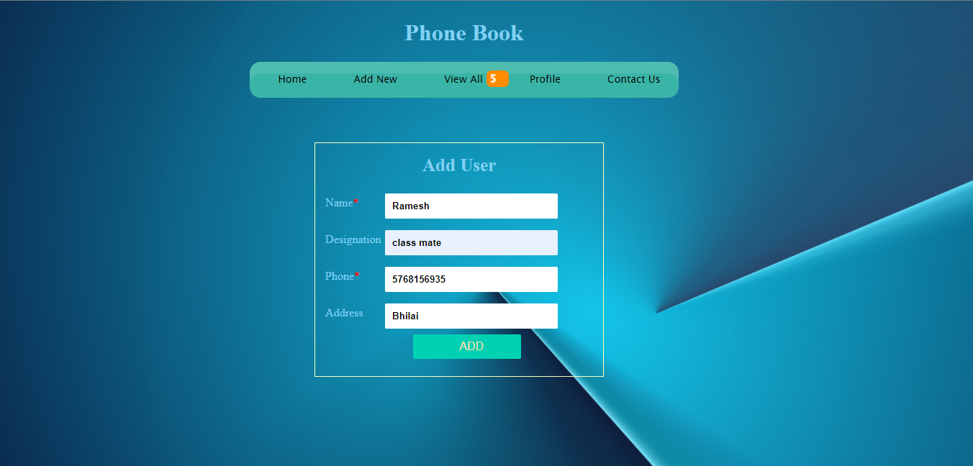
( Fig :- 03 Add user page)

This is the “Add New contact” page of the website. This page is created to add new contacts in PhoneBook .

This page contains the name, designation, phone number and address. The list consists of multiple columns like student Name, Designation, Phone and Address.

* View All Records :

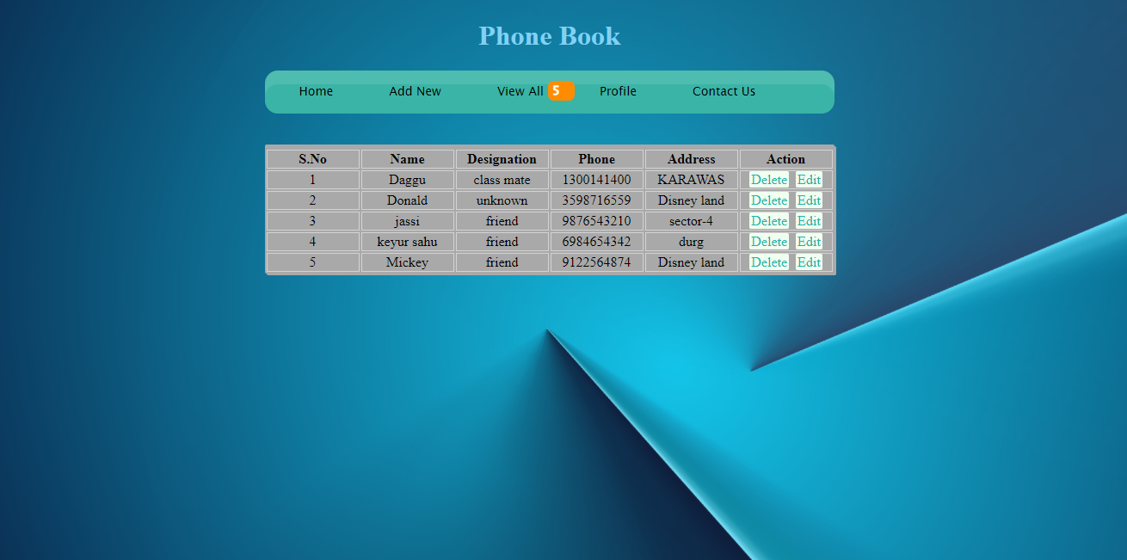
( Fig :- 04 View page)

This is the “View All Contact” page of the website. Through this page admin can see the all contact records, which was saved by the admin.

Through this page the admin can see the all saved contacts, and also he can edit or delete those contacts.

* View profile :

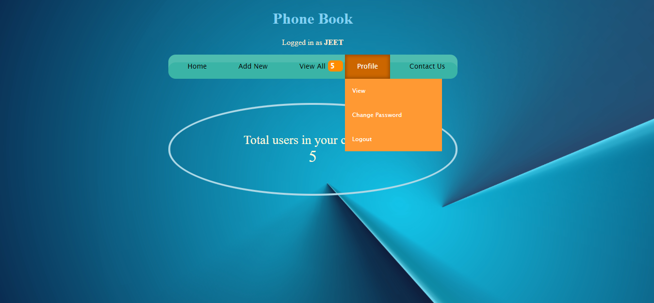
( Fig :- 05 Profile setting page)

This is the “Profile page” of the website. This page contains the View, change password and Logout menu.

Through this the admin can view his profile , change the password and also can logout from the current login id. In view profile menu the user can change or edit his information like user name etc.

Conclusion and Future work

- We should be no longer needed to make spread-sheets, tables etc. just to store phone numbers.
- With the use of this phonebook program we can keep contact archives of our family membes, friends etc.
- We can always see the phone numbers on our desktop.
- As the technology emerges, it is possible to upgrade the system.
- Security can be improves using emerging technologies.
- This software is developed using as frontend and MYSQL local server.
- This phonebook is user friendly and provide efficient management of records.

